**First Stage Results**

**Using change in Naïve Bayes predictability between step 1 and 2**

Cut point step 2 predictability>=0.8, Log(change in predictability)>=0

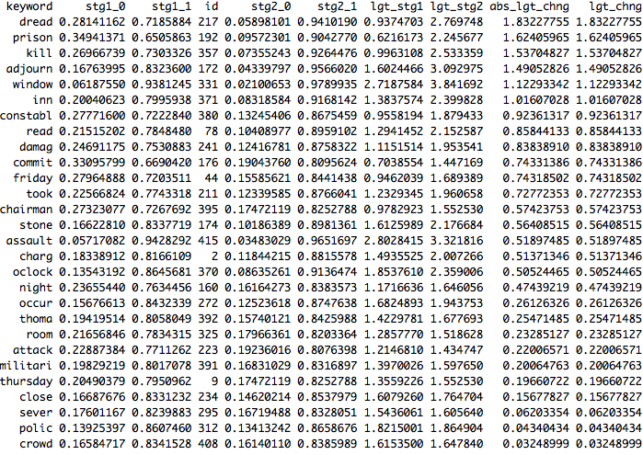

**Using the number of co-ouccurence across top keywords from step 1 for top keywords in step2**

Cut point to determine top keywords in step 1 and 2 >=0.8

